Day 50 – 1:8 DEMUX Using Verilog.

Introduction:A 1:8 Demultiplexer (DEMUX) is a combinational circuit that takes one input and sends it to one of eight outputs based on the three select lines.
In this design, a 1:8 DEMUX is implemented using Verilog HDL and verified through simulation and waveform analysis in Xilinx Vivado.

Design:The 1:8 DEMUX consists of:
- 1 Data Input: I
- 3 Select Inputs: S0, S1, S2
- 8 Outputs: Y0 to Y7
The three select lines decide which output receives the input.

Design Code:

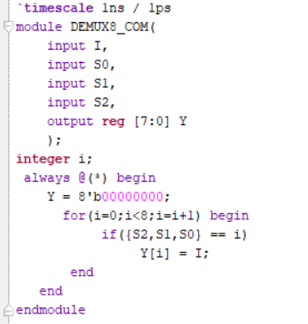

Testbench:The testbench is used to apply different combinations of the input and select lines and verify the outputs.

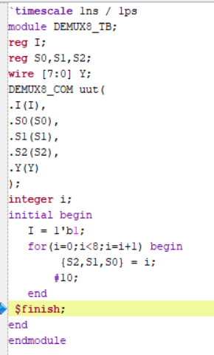

Waveform:The waveform verifies that the input is routed to the selected output while the remaining outputs stay 0.

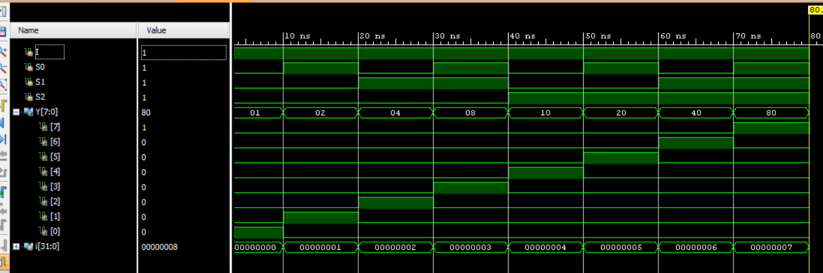

Schematic:

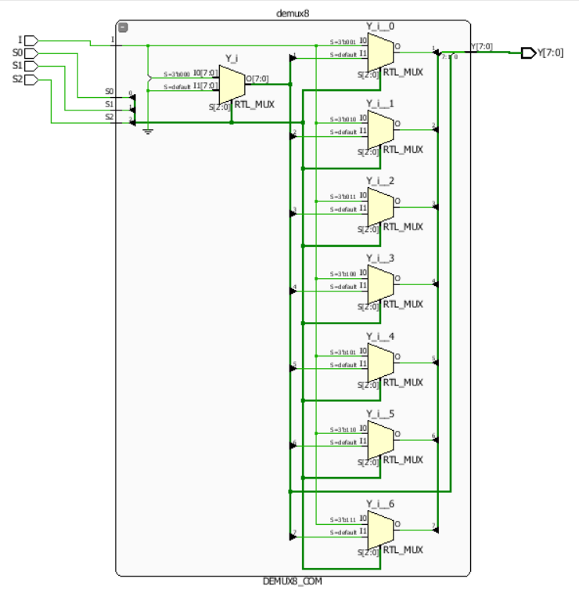

Observation:The 1:8 DEMUX successfully routes the single input to the selected output according to the three select lines.

#PHANEENDRA.SINGUDASU

